Circuit Breaking

Apply DestinationRule with Circuit Breaker for httpbin

Check httpbin DestinationRule

Deploy fortio Client

Test fortio → httpbin:8000 GET (Baseline)

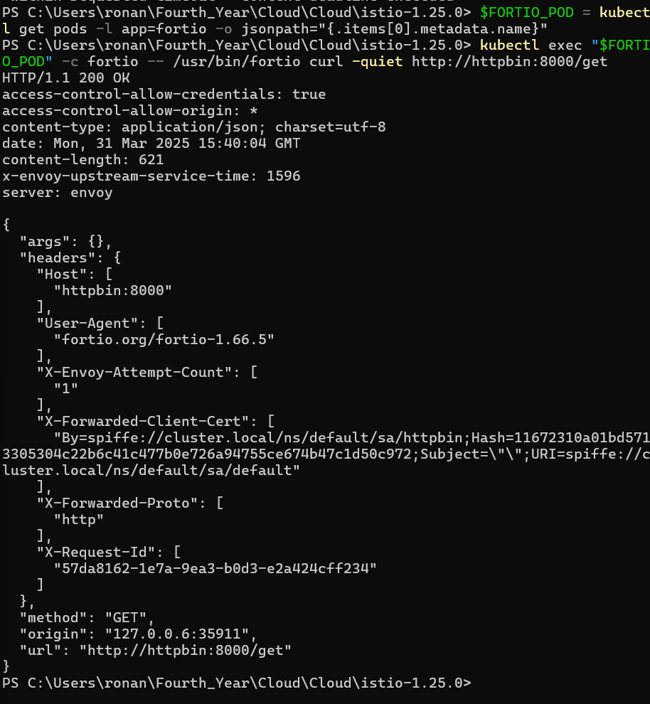

*Trip Circuit Breaker with 2 Conns, 20 Requests*

Trigger Stronger Circuit Breaker (3 Conns, 30 Req)

Check Istio Proxy Stats – Circuit Breaker Metrics

